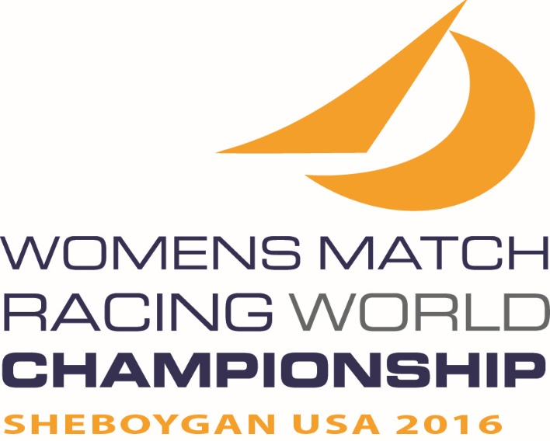

    

**2016**

**WORLD SAILING**

**Women’s Match Racing World Championship**

**Sheboygan, WI, USA**

**19– 25 September 2016**

EVENT INFORMATION

**Hosted by Sail Sheboygan and Sheboygan Yacht Club**

On behalf of Sail Sheboygan and Sheboygan Yacht Club, it is our pleasure to inform you of the 2016 Women’s Match Racing World Championship. The event will take place in Sheboygan, Wisconsin, USA from Monday September 19 through Sunday September 25, 2016. The Notice of Race may be found on the Sail Sheboygan website at: <http://www.sailsheboygan.org/2016-womens-match-racing-worlds-2/>

**Registration**

The Race Office, located at the Sheboygan Yacht Club, will be open for registration and weighing Monday, September 19 from 1000 to 1700 CDT.

**Practice**

Elliott 6m boats will be available for practice Monday, September 19 from 1200 to 1700 and again on Tuesday, September 20 from 1000 to 1500. Practice shall be only during specified practice times. Competitors must complete all registration requirements, pay all fees, and provide a damage deposit before being assigned a boat for practice.

**Racing**

Racing days will be Wednesday September 21 through Sunday September 25, 2016. A combination of Round Robins and Knock-out matches is planned to maximize racing for all competitors.

**Lodging**

Lodging within walking distance of the Sail Sheboygan facilities include:

* Blue Harbor Resort, Villas and Water-park [www.blueharborresort.com](http://www.blueharborresort.com)
* Grand Stay Hotel  [www.](http://www.grandstaysheboygan.com/" \t "_blank)[[grandstaysheboygan.com](http://www.grandstaysheboygan.com/" \t "_blank)](file:///C:\Users\Kathy%20Lindgren\Documents\My%20Dropbox\USSCS%20Projects\2012\Buddy%20Melges%20Challenge\grandstaysheboygan.com)

Sail Sheboygan has made arrangements with several hotels of different price ranges to keep sailors, crew and families together. The price range per night is Economy at $50 to 85 USD, mid-point at $85 to 125 USD, and high end beginning at $300 USD.

Additional hotels and information can be found at [www.visitsheboygan.com/stay/lodging](http://www.visitsheboygan.com/stay/lodging).

Upon request and availability, housing may be provided to competitors in private homes of Sheboygan area residents.

**Transportation**

Milwaukee General Mitchell Airport (MKE) and Chicago O’Hare International Airport (ORD) serve the area. Milwaukee is approximately a 1 hour drive from Sheboygan. Chicago ORD is approximately a 2 ½ hour drive from Sheboygan. Airport Limousine and shuttle services are readily available to both Milwaukee and Sheboygan. Wisconsin Coach Lines operates an hourly bus service between ORD and MKE. Information regarding schedules and costs can be found at: <http://www.coachusa.com/wisconsincoach/ss.ohareairport.asp> Go Riteway provides airport shuttle services from both MKE and ORD to Sheboygan. Visit <http://goriteway.com/> for information.

**Social**

The Organizing Authority is planning several social events throughout the event. The dress attire will be sailor casual.

**Weather**

Links for local weather can be found on our website or at the following [www.sailsheboygan.org/?page\_id=109](http://www.sailsheboygan.org/?page_id=109) The Lake Michigan water temperature is approximately 15 to 20 degrees cooler than air temperature this time of year. This temperature difference helps to provide dependable breezes, but you may find you need additional clothing layers.

**Confirm Acceptance**

Please note that in order to remain eligible, you are required to confirm your acceptance to Rich Reichelsdorfer via e-mail at [rich@windway.com](mailto:rich@windway.com)  and pay the non-refundable entry bond of $250 (US dollars) by July 1, 2016. Payment may be made via PayPal or check.

**Information**

Contact Rich Reichelsdorfer [rich@windway.com](mailto:rich@windway.com) for more information.

We look forward to your response,

Sail Sheboygan

P.O. Box 649

Sheboygan, WI 53082-0649

+1 (920)-889-0758

**2016**

**WORLD SAILING**

**Women’s Match Racing World Championship**

**Sheboygan, WI, USA**

**19– 25 September 2016**

APPLICATION FORM

To: Rich Reichelsdorfer

PO Box 649

Sheboygan, WI USA 53082-0649

**E-mail rich@windway.com**

copy: WIM Series Manager Liz@wimseries.com

Skipper’s name: \_\_\_\_\_\_\_\_\_\_\_\_\_\_\_\_\_\_\_\_\_\_\_\_\_\_\_\_\_\_\_\_\_\_\_\_\_\_ ISAF ID: \_\_\_\_\_\_\_\_

Address: \_\_\_\_\_\_\_\_\_\_\_\_\_\_\_\_\_\_\_\_\_\_\_\_\_\_\_\_\_\_\_\_\_\_\_\_\_\_\_\_\_\_\_\_\_\_\_\_\_\_\_\_\_\_\_\_\_\_\_

City: \_\_\_\_\_\_\_\_\_\_\_\_\_\_\_\_\_\_\_\_\_\_\_\_\_\_\_\_\_\_\_ Country: \_\_\_\_\_\_\_\_\_\_\_\_\_\_\_\_\_\_\_\_\_\_\_\_

Postal code: \_\_\_\_\_\_\_\_\_\_\_\_\_\_\_\_\_\_\_\_\_

Mobile Phone (include country code)\_\_\_\_\_\_\_\_\_\_\_\_\_\_\_\_\_\_\_\_\_\_\_\_

Email\_\_\_\_\_\_\_\_\_\_\_\_\_\_\_\_\_\_\_\_\_\_\_\_\_\_\_\_\_\_\_\_\_\_\_

Name of Club: \_\_\_\_\_\_\_\_\_\_\_\_\_\_\_\_\_\_\_\_\_\_\_\_\_\_\_\_\_\_\_\_\_\_\_\_\_\_\_\_\_\_\_\_\_\_\_\_\_\_\_\_\_\_

Crew 1 \_\_\_\_\_\_\_\_\_\_\_\_\_\_\_\_\_\_\_\_\_\_\_\_\_\_\_\_\_\_\_\_\_\_\_\_\_\_\_\_\_\_\_\_ISAF ID: \_\_\_\_\_\_\_\_\_\_\_

Crew 2 \_\_\_\_\_\_\_\_\_\_\_\_\_\_\_\_\_\_\_\_\_\_\_\_\_\_\_\_\_\_\_\_\_\_\_\_\_\_\_\_\_\_\_\_ISAF ID: \_\_\_\_\_\_\_\_\_\_\_

Crew 3 (if sailing with 4) \_\_\_\_\_\_\_\_\_\_\_\_\_\_\_\_\_\_\_\_\_\_\_\_\_\_\_\_\_\_ISAF ID: \_\_\_\_\_\_\_\_\_\_\_

DECLARATION:

I hereby agree to be bound by the Racing Rules of Sailing and by all other rules that govern this event, and also confirm my entry bond fee of $250 US

Signature (Skipper): \_\_\_\_\_\_\_\_\_\_\_\_\_\_\_\_\_\_\_\_\_\_\_\_\_\_\_\_\_\_

Name: \_\_\_\_\_\_\_\_\_\_\_\_\_\_\_\_\_\_\_\_\_\_\_\_\_\_\_\_\_\_\_\_\_\_\_\_\_\_\_\_\_

Date: \_\_\_\_\_\_\_\_\_\_\_\_\_\_\_\_\_\_\_\_\_\_\_\_\_\_\_\_\_\_\_\_\_\_\_\_\_\_\_\_\_\_