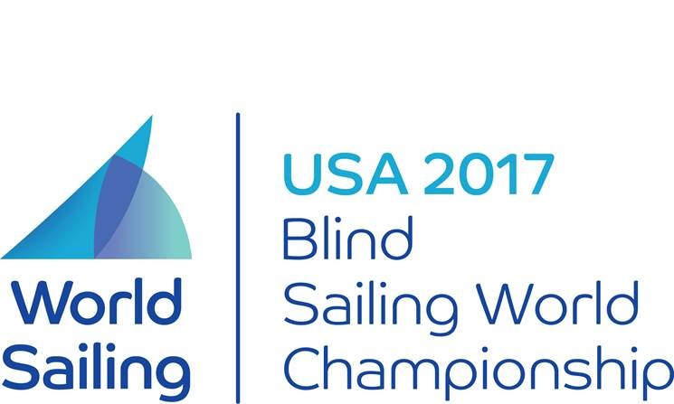

TEAMS

B1 Division

GBR - Skipper: Sharon Grennan  
 Main: Catherine Westbrook

Tactician: Martin Moody

Trimmer: Ian Shirra

USA - Skipper: Duane Farrar

Team Wind Whisperers  
 Main: Amy Bower

Tactician: Denis Bell

Trimmer: Andrew Alletag

USA - Skipper: Walter Raineri

Team BAADS  
 Main: BJ Blahnik

Tactician: Andrew Wilkonson

Trimmer: Jason Berdyck

USA - Skipper: Scott Ford   
Warrior Sailing  
 Main: Kris Scheppe

Tactician: Stacie Straw

Trimmer: Rachelle Pontes

NZ - Skipper: Mark Mulcare  
 Main: Tony Holmes

Tactician: Terry Valder

Trimmer: David Steffensen

AUS - Skipper: Kylie Forth

Lost at See  
 Main: Erin McGlew

Tactician: Justin Kelleher

Trimmer: Fiona McCabe



TEAMS

B2 Division

CAN - Skipper: David Brown  
 Main: Brian Arthur

Tactician: Ross Adams

Trimmer: Charles Nevel

GBR - Skipper: Lucy Hodges  
 Main: Toby Davey

Tactician: Ben Hazeldine

Trimmer: Colin Midgley

USA - Skipper: Pauline Dowell  
 Main: Christian Thaxton

Tactician: Kay VanValkenburgh

Trimmer: Sarah Jacklin

B3 Division

GBR - Skipper: Laura Cammidge  
 Main: Chris Albert

Tactician: Jonny Cormack

Trimmer: Jonny Stevenson

GBR - Skipper: Mark Austen  
 Main: Sally Rodgrigues

Tactician: Justin Smith

Trimmer: David Hawkins

CAN - Skipper: Chris Jonas  
 Main: Jodi Munden

Tactician: Andrew Wilkinson

Trimmer: Renee Charpentier

USA - Skipper: Kris Scheppe

Main: Scott Ford

Tactician: Stacie Straw

Trimmer: Rachelle Pontes

USA - Skipper: Willi Fontanez

Tree Takers  
 Main: Katherine Kern

Tactician: Leo Gaskell

Trimmer: Grace Olsen